
^{25th} Annual Tax Conference Agenda

Tuesday, November 5-6, 2024

Noon-4 Conference Pre-Registration NITA
Monday November 4, 2024 Welcome Reception Come and Go at 5-7pm4
Day 1 – Tuesday, November 5, 2024

7:30-8:00 am Registration and Breakfast
Opening Prayer TBA
8:00-8:30 am Welcome and Opening Remarks - Mary Mashunkashey, Tax Commissioner Muscogee Creek Nation/NITA Chair, Ak Chin Representative

KEYNOTE ADDRESS
8:30-9:15 am
Speaker: TBA
General Session 1 – Legislative Update
9:15-10:15 am
Moderator: TBA
Panelists:
10:15-10:30 Break
10:30-11:30 am
General Session 2– Tobacco Compacts, Cougar Den Discussion

Moderator: TBA
Panelists:
General Session 3– Dual Taxation
11:30-12:30 pm

Moderator:
Panelists: Michael Walch
12:30 – 1:30pm Lunch on your own
1:30 – 2:45pm
General Session 4– GWE Update

Moderator:
Panelists:
2:45 – 3:00pm Break
3:00-4:00pm
General Session 5– NAFOA/NCAI Update

Moderator:
Panelists:
4:00-5:00 pm
Breakout Session A- VITA

Moderator: Mary Mashunkashey, Tax Commissioner, Muscogee Creek Nation/NITA Chair
Panelists:
Breakout Session B- Direct Pay for Tax Credits

Moderator:
Panelists:
Breakout Session C- ERISA Litigation

Moderator:
Panelists:

Day 2 – Wednesday November 6, 2024

7:30-8:30am Breakfast
8:30-9:00 am Opening Prayer TBA Opening Remarks Mary Mashunkashey, Tax Commissioner Muscogee Creek Nation, NITA Chair
9:00-10:00 am
General Session: 6- Treasury Update

Moderator:
Panelists:
10:15-11:15 am
General Session 7- Litigation Update

Moderator:
Panelists:
Break 11:15-11:30

11:30-12:30 pm
General Session 8– IRS/TTAC Update

Moderator:
Panelists:
12:30-1:30 Lunch on your own

1:30-2:45
General Session 4 – GWE Update

Moderator:
Panelists:
2:30-2:45 pm Break
3:00-4:00 pm
Breakout Session D-

Moderator:

Panelists:

Breakout Session E – National TERO Update

Moderator: Kelcey Packineau, MHA Nation TERO, Calvin Harlan Omaha Tribal Council/Chairman TERO

Panelists:

Breakout Session F- Best Practices for RAP

Moderator:
Panelists:

4:00-5:00 pm
Breakout Session F- TAX 101 Training
Moderator: Bruce Zimmerman NITA Treasurer, Umatilla Tax Department & Sharon Swepston NITA Executive Board, Cherokee Nation Tax Commission

4:00-5:00 pm
Breakout Session F-

Moderator:

Panelists:

Breakout Session G-

Moderator:

Panelists:

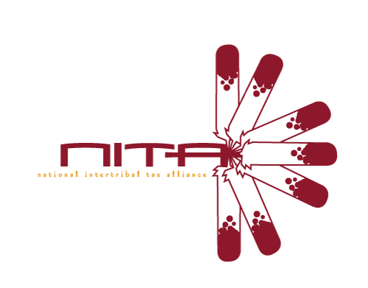
Closing Remarks – NITA Board of Directors

Adjournment
Board of Directors Dinner Meeting@6pm Monday

Thank you for supporting the National Intertribal Tax Alliance!

