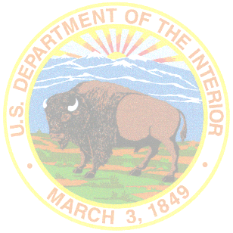
Tribal/Interior Budget Council

Data Management Subcommittee Meeting
Agenda

November 6, 2023
10:15 a.m. – 12:15 p.m.
Tribal Subcommittee Co-Chairs:
Rick Harrison, Chickaloon Village

Federal Subcommittee Co-Chair:
Veronica Lane, Chief Data Officer, OBPM
Karen Frejo, Management Analyst, BIA

- Welcome and Opening Remarks
- Voting Member Roll Call
- Issues/Update
  - Bureau of Labor Statistics (BLS) – Vernon Brundage, Patrick Carey, BLS
  - Performance Management Update, Karen Frejo, BIA
    - Benchmark Report Update
      - Additional Line Items/National Norms for FY26 Submission
      - Current Line Items adjustments/justifications
  - Office of Budget Performance Management, Veronica Lane, OBPM
    - Define “Data” Update
    - Data Sovereignty Discussion
- Summary of Action Items for Report Out
- Adjourn

